Purpose
To establish a procedure on how to orient, gross and sample hysterectomies for endometrial cancer and EIN.

Procedure
For Endometrial Cancer or EIN
- Determine orientation of the specimen. Anterior will have a bladder reflection that is higher than the tapered posterior reflection. Adnexa are posterior to the round ligament and the fallopian tube is anterior to the ovary.
- Weigh the uterus and cervix and measure the uterus from superior to inferior, cornu to cornu and anterior to posterior.
- Measure adnexa if present stating measurements of right and left ovaries and fallopian tubes.
- Describe uterine serosa if abnormal i.e.: adhesions present, nodules and/or defects.
- Ink anterior and posterior cervical stromal margins different colors.
- If the fallopian tubes are attached, ink the area where the fallopian tubes attach to the uterus (one color for right and one color for left). If the fallopian tubes are detached, locate where the fallopian tubes were attached and ink (one color for right and one color for left).
- Describe the ectocervical mucosa, shape of the cervical os, and if the endocervical canal is patent.
- Bivalve the uterus and cervix into anterior and posterior halves using scissors or a straight blade.
- Describe the endometrial lesion, if present (polypoid, papillary, exophytic, etc.) and include the size, location, and distance to the lower uterine segment.
- Serially section the uterus from fundus to the lower uterine segment.
- Describe the cut surface of the lesion and measure distance to serosa and depth of invasion. Make sure to dictate if the lesion extent is in the inner half of the myometrium or the outer half of the myometrium. Measure the thickness of the myometrium where the lesion has the greatest depth of invasion.
- If a lesion is not identified, describe the endometrium and give the maximum thickness. (follow sections for EIN submission).
- Describe the uninvolved myometrium (trabecular, cysts or nodules present and size in greatest dimension) and thickness of uninvolved myometrium.
- If present, describe the ovaries and fallopian tubes.

Sections for Endometrial Cancer:
- One longitudinal full thickness section each of the anterior and posterior cervix including the transformation zone (endo and ecto cervix).
- One longitudinal full thickness section each of the anterior and posterior lower uterine segment
- At least four full thickness sections, or 1 section per centimeter. Submitted sections should include the deepest extent of myometrial invasion, as well as any foci with different gross appearances. If the full thickness section is too large to fit in one cassette, bisect the section through the myometrium so one half has endometrial lesion and the second half has serosa.
- One full thickness section from uninvolved endometrium.
- Any additional findings (nodules, polyps).
- One section each from right and left where fallopian tube attaches to uterus in one cassette (cross section).
- If present, 1 section of each right and left ovary if grossly normal. One cassette for right and left fallopian tubes. The fimbria must be completely submitted.

Sections For EIN (Endometrial Atypical Hyperplasia / Endometrioid Intraepithelial Neoplasia):
- One full thickness longitudinal section each of anterior and posterior cervix including the transformation zone (endo and ecto cervix)
- One full thickness longitudinal section each of anterior and posterior lower uterine segment.
- Submit all the endometrium. Submit anterior half first with at least one full thickness section and the remaining can be shaves of endometrium and superficial myometrium. 1-2 pieces can be placed in one cassette (shaved section should be about 0.5 cm in thickness). Repeat for posterior endometrium.
- Any additional findings
- One cassette each for right and left ovaries. One cassette each for right and left fallopian tubes. The fimbria must be completely submitted.

Anterior
(Peritoneal reflection is higher and more blunt. Fallopian tube is anterior to the ovary)
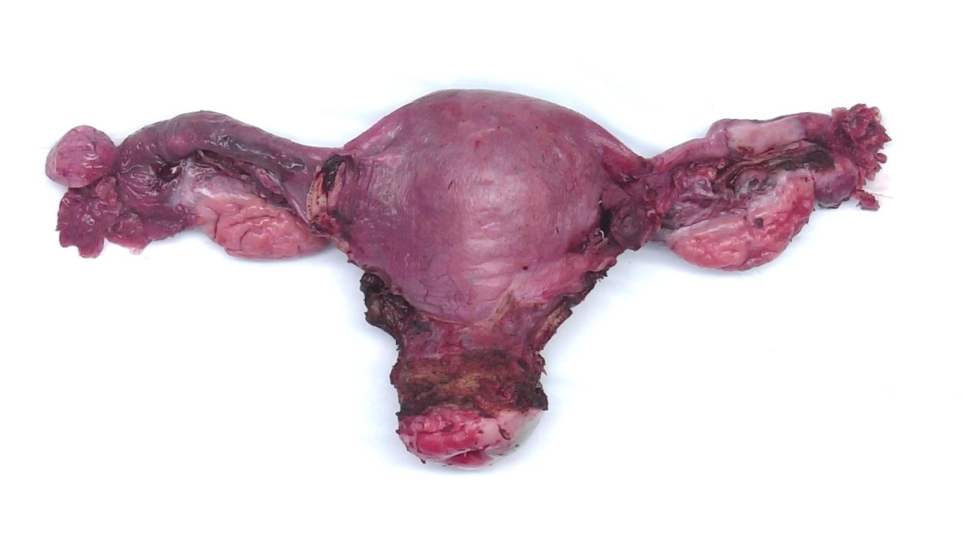

Posterior
(Peritoneal reflection is lower. Ovary is posterior to the fallopian tube)
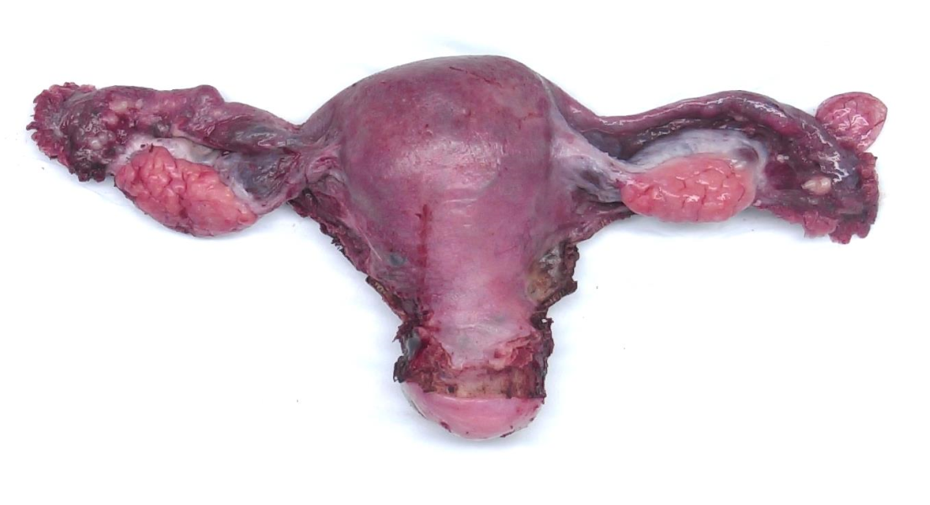
Inking and taking sections of fallopian tube insertion (for endometrial cancer)

